To: Honorable Mayor of Seattle, Ed Murray
CC: Honorable Councilmember, Bruce Harrell; Chief Technology Officer, Erin Devoto; Director of Policy and Innovation, Robert Feldstein; CTTAB members
Date: January 15, 2014
Re: Broadband in Seattle post-Gigabit Squared

Though we are disappointed in light of recent news that the Gigabit Squared initiative with Seattle no longer seems viable, the Citizens Telecommunications and Technology Advisory Board (CTTAB) wants to be clear in reaffirming our earlier position on broadband for the City:

The Citizens Telecommunications and Technology Advisory Board (CTTAB) urges the Mayor and the Council to move forward without further delay to bring a Fiber-to-the-Premise network to Seattle.

While much has changed with technology in the last several years with respect to broadband, the issues of affordability, access, reliability and consumer choice still persist throughout the City. As stated in our 2010 position statement:

Access to a broadband internet connection at all premises in the city is the critical – indeed, the cornerstone – technology that will enable Seattle's citizens, businesses and institutions to compete and thrive in the global marketplace. State-of-the-art internet access is essential to Seattle's ability to compete and lead in the 21st Century global economy. CTTAB envisions access to the internet for all Seattle citizens, businesses, and institutions that is fast, fair, and everywhere.

In order to help move things along for improving broadband throughout the City, we recommend:

- Continuing to work with the Seattle Department of Transportation on looking at changes to the Director's Rule which would help improve broadband access, choice and reliability
- Continuing the evaluation of responses to the excess fiber leasing ordinance (Ordinance 123931)
- Updating earlier studies on feasibility (2007) and benefits (2009) for FTTP solutions to take into account changes in the overall marketplace and technological advances
- Updating the 2004 report on FTTP to take into account changes in the marketplace and overall technological advances

CTTAB, of course, makes itself available to assist in these endeavors – and any others – that will help bring about improved broadband access for all residents of Seattle.

Sincerely,

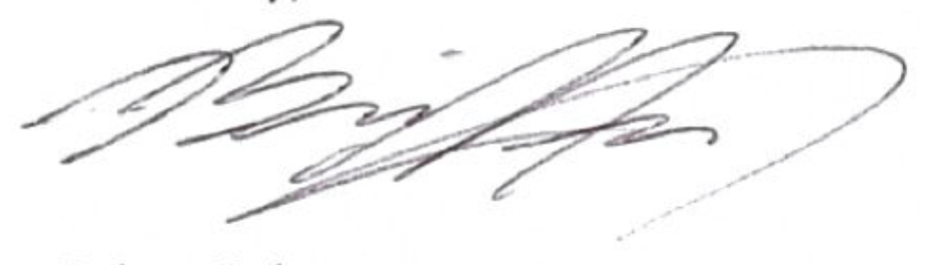

Brian Hsi, Chair of the Broadband and Cable committee,
on behalf of the Citizens’ Telecommunications and Technology Advisory Board

Cc:
Councilmember Bruce Harrell
Erin Devoto, Chief Technology Officer
Robert Feldstein, Director of Policy and Innovation
Members of CTTAB

